|  |
| --- |
| **COLÉGIO NOSSA SENHORA DE LOURDES**  **6º ANO**  **ENSINO FUNDAMENTAL -2015** |

**Roteiro de estudos para recuperação trimestral**

|  |  |
| --- | --- |
| **Disciplina:** | Inglês |
| **Professor (a):** | LENINHA |

|  |  |
| --- | --- |
| **Conteúdo:** | Interpretação texto  Simple Present Tense  Cardinal and Ordinal Numbers.  Horas  Frequency Adverbs  Vocabulary: food and housechores |
| **Referência para estudo:** | Apostila do Pitágoras págs. 51 a 65  Estudar as Avaliações aplicadas no trimestre e trabalho  folha de exercícios trabalhados (revisões) |
|  |  |
| **Atividade avaliativa:** |  |

**QUESTÃO 01**

Read the text and answer question1.

**Boy:** Hi, my name is Peter. I get up at 6:15. I take a shower and have breakfast. Then I have to run because the school bus picks me up at 6:45. I’m never late for school. When I come home from school I am hungry. I usually have lunch at 12:45 p.m. I always go to bed at 9:00 p.m. because I have to get up early the next morning.

**Girl:** Hello, my name is Mary. I usually get up at 8:00. I don’t have breakfast. I sometimes have lunch at 11:30. I study in the afternoon. I go to school at 12:30 o’clock. I’m sometimes late for school. I always go to bed at 10:30 p.m. because I get up late.

Match the questions with the answers.

|  |  |
| --- | --- |
| a. What time does Peter get up?  b. What time does Peter take the bus to school?  c. What time does he have lunch?  d. What does Mary do at eight o’clock?  e. What does she do at twelve thirty?  f. What time does she go to bed? | ( ) She goes to school.  ( ) At six fifteen.  ( ) At ten thirty.  ( ) At six forty-five.  ( ) She gets up.  ( ) At twelve forty-five. |

1. e, a, f, b, d, c
2. b, d, e, a, c, f
3. f, b, c, d, a, e
4. d, c, a, f, e, b

**TEXT**

Read the text and answer **question 02.**

What are Italian People like?

**Buon giorno!  My name is Mario and I live in Sicily, Italy.**

**I have two brothers; one is named Salvatore, who is thirteen, and Alfonso, who is two.  I have two sisters Maria, who is eight and Caterina, who is two and she is Alfonso’s twin sister.  I am ten years old.**

**We love to cook - and eat!  We eat our main meal at midday, and it always has a pasta course.**

**The most popular meats that we eat are veal and pork. We also love to eat cheese.**

**Some sports in my country are basketball, soccer, and Formula 1 racing.  The most popular sport is soccer.**

**In January, the temperature is usually between 50 and 60 degrees, but it gets very hot in the summer, (up to 95 degrees) and that is when my family and friends love to go to the beaches.**



http://library.thinkquest.org/CR0212302/italy.html

**Vocabulary:** Veal – vitela

**QUESTÃO 02**

Match the correct information.

|  |  |
| --- | --- |
| 1. Mario lives in  2. He has  3. According to Mario Italian people like  4. Italian people usually eat  5. They love to | ( ) at midday.  ( ) Sicily, Italy.  ( ) two brothers and two sisters.  ( ) eat cheese.  ( ) to cook – and eat. |

(A) 3, 1, 2, 4, 5

(B) 1, 5, 3, 2, 4

(C) 2, 3, 1, 4, 5

(D) 4, 1, 2, 5, 3

**QUESTÃO 03**

Write in English the “ordinal numbers” below. Escrever por extenso.

a) 3rd g) 1st

b) 10th h) 18th

c) 5th i) 20th

d) 19th j) 2nd

e) 4th k) 11th

f) 15th l) 21st

**Questão 04**

Read the text below and fill in the blanks with the appropriate words from the box.

Sports - children - jobs - school - hours - world

Children @ work

Hi again!

Youth in many parts of the _________are going to school and also holding part time jobs. These small ____________ help them learn responsibility. Some jobs might include delivering newspapers and babysitting younger __________. You spend many ___________ in school and at home studying and when ___________ is over for the day you like to engage in leisure activities for kids your age. Perhaps playing ____________ is one of your favorite things to do when you are not in school.

**QUESTÃO 05**

Leia a lista de tarefas domésticas abaixo e escreva em Inglês qual tarefa está representada em cada desenho abaixo.

**8-10 year olds 11 year olds and older**

- make bed - All the previous chores plus   
- water plants - take garbage out

- clean room - wash dishes   
- set the table - clean the bathroom with direction

- clean the table - clean the kitchen  
- dust - help with laundry and eventually  
- vacuum - start doing own laundry  
- feed pets - help make dinner

- put laundry in hamper - help wash the car/wash car  
- help wash the car - help with yard work

a)_________________ b) __________________ c) ____________________

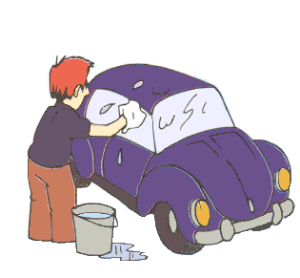 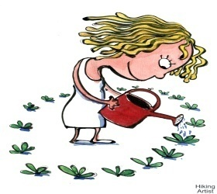 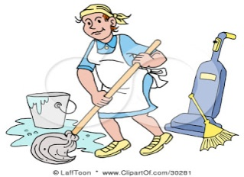

d) _________________ e)__________________ f) _____________________

  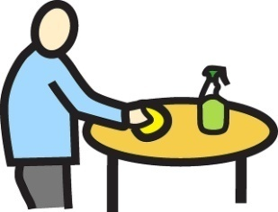

**QUESTÃO 06**

Answer these questions about your routine. Use **ALWAYS, NEVER, SOMETIMES** and **USUALLY**.

1. How often do you get up early?

____________________________________________________________________________

2. How often do you have breakfast?

____________________________________________________________________________

3. How often do you go to school?

____________________________________________________________________________

4. How often does your mother go to bed late?

____________________________________________________________________________

**TEXT**

**Read the text below and answer questions 07 and 08.**

**Whose food is it?**

**Sally:** I like apple, strawberry, orange, vegetables and apple, but I don´t like fast food.

**Peter:** I like hamburguer, apple, vegetables and fish, but I don´t like bananas.

**Rick:** I like pizza, fruits, hamburguer, fast food and pear, but I don´t like carrots.

**Lucy:** I like chicken, eggs, carrot, and hamburguers, but I don´t fruits .

**Questão 07**

**a. This is __________________’s food.**

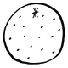 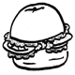  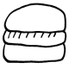 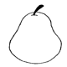

**b. This is __________________’s food.**

 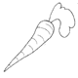  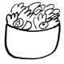 

**c. This is __________________’s food.**

 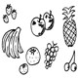 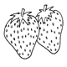 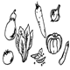 

**d. This is __________________’s food.**

   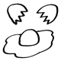 

**QUESTÃO 08**

Write **TRUE** or **FALSE**:

a. Sally´s favorite food is fruit and vegetable. ( )

b. Peter´s favorite food is fruit, hamburguer, fish and carrot. ( )

c. Rick´s favorite food is fast food and fruit. ( )

d. Lucy´s favorite food is vegetable and fruit. ( )

**A –** T,T,F,F

**B –** F,T,F,T

**C –** T,F,T,F

**D –** F,F,T,T

**Questão 09**

Answer the questions below using the words from the box.

ONION – GRAPE – EGGPLANT – ORANGE – LETTUCE – CARROT – PAPAYA – BROCCOLLI - LEMON – BANANA – TOMATO – APPLE – POTATO – STRAWBERRY – CORN – PEAR – PINEAPPLE

1. What do you need to make a fruit salad?
   1. __________________
   2. __________________
   3. __________________
   4. __________________
   5. __________________
   6. __________________
   7. __________________
2. What do you need to make a vegetable salad?
   1. __________________
   2. __________________
   3. __________________
   4. __________________
   5. __________________
   6. __________________
   7. __________________

**QUESTÃO 10**

Write (por extenso) the results.

1. 25 : 5 = _________________
2. 35 : 5 = _________________
3. 3 X 6 = _________________
4. 4 X 4 = _________________
5. 35 – 18 = _________________

**QUESTÃO 11**

Put the verbs below in the third person of the singular (3ª pessoa do singular)

A) Brush B) Go C) Buy

D) Work E) Study F) Have

G) Wake up H) Finish I) Arrive

**QUESTÃO 12**

According to the household chores you do at home. Write affirmative or negative sentences about yourself. Use o Simple Present Tense.

a) Take garbage out. __________________________________________________.

b) Clean the table. ____________________________________________________.

c) Wash dishes. ______________________________________________________.

d) Clean the bathroom. ________________________________________________.

e) Make my bed. _____________________________________________________.